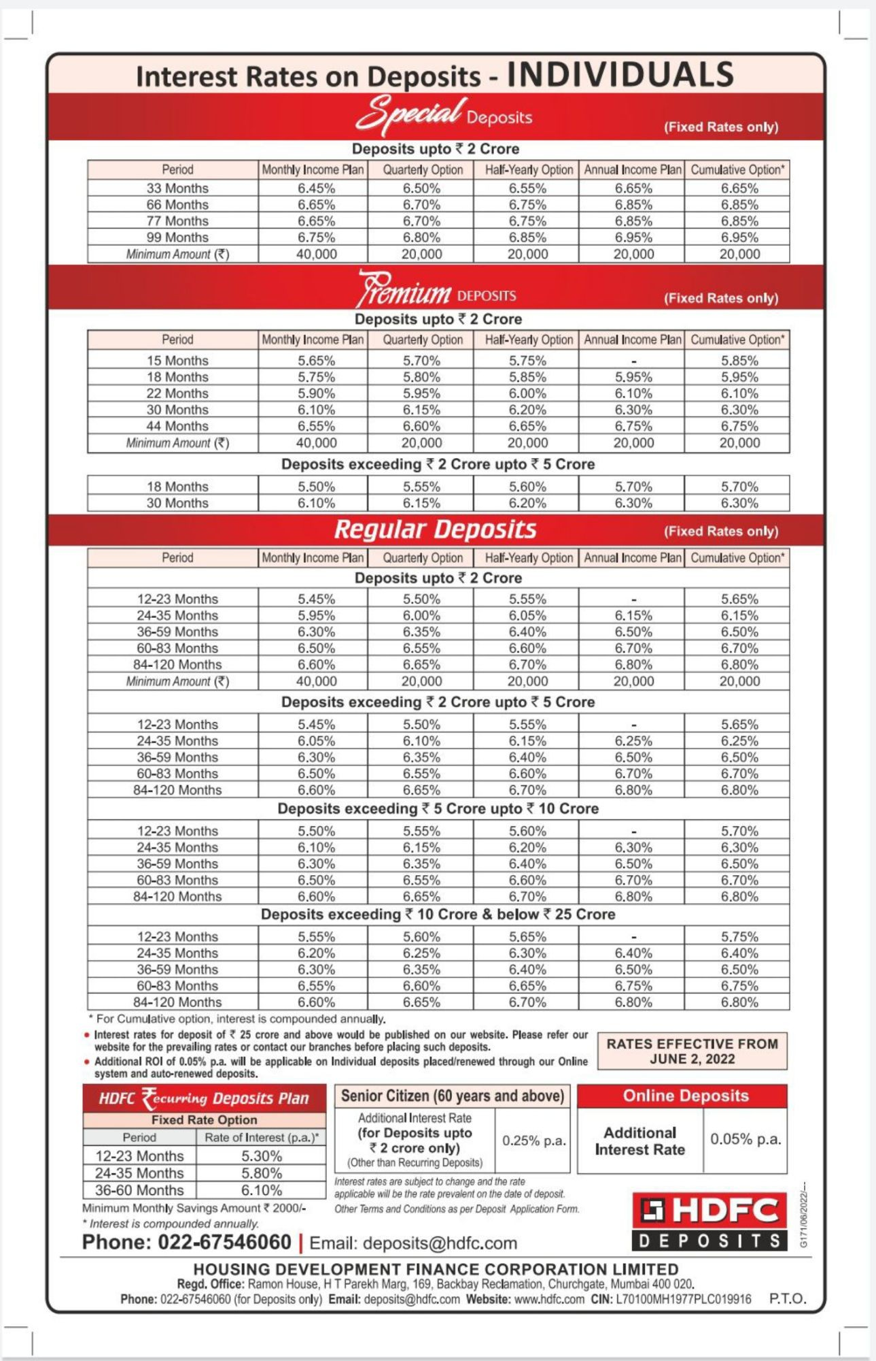

Process note:
Ensure code is mentioned CODE - BM/52459 - IIFL SECURITIES LIMITED
You can place new deposits online instantly. You do not need to submit any documentation in the online process.
Link for Online deposits: https://online.hdfc.com/hdfcdeposits
Click here to watch the video containing steps for New Deposit Placement through HDFC Deposits Online System: https://www.youtube.com/watch?v=CvtjBHQAVmM
Please click on the below link for details of remittance modes for placement of deposits
https://www.hdfc.com/modes-of-remiitance-of-funds-for-placement-of-deposits
You can renew fixed deposits online instantly. You do not need to submit any documentation in the online process.
Link for Online renewal: https://online.hdfc.com/hdfcdeposits
Click here to watch the video containing steps for Deposit Renewal through HDFC Deposits Online System: https://www.youtube.com/watch?v=sHIO5NwvZMg
You can process repayment of deposits online instantly. You do not need to submit any documentation in the online process.
Link for Online Repayment: https://online.hdfc.com/hdfcdeposits
Click here to watch the video containing steps for Deposit Repayment through HDFC Deposits Online System: https://www.youtube.com/watch?v=BLRzK-0vTQc

